Cairo University  
Faculty of Computers and Information



**CS251**

**Software Engineering I**

GOFO

Software Design Specifications

Contents

Cairo University Faculty of Computers and Information 1

Contents 2

Team 3

Document Purpose and Audience 3

System Models 4

I. Class Diagram(s) 4

II. Class Descriptions 5

III. Sequence diagrams 6

Class - Sequence Usage Table 9

IV. User Interface Design 10

Tools 12

Ownership Report 12

Screenshots and Video 13

# Team

|  |  |  |  |
| --- | --- | --- | --- |
| **ID** | **Name** | **Email** | **Mobile** |
| 20180250 | Mahmoud Ashraf | [ma5027300@gmail.com](mailto:ma5027300@gmail.com) | 01102488789 |
| 20180304 | Nader Fikry | [naderfikry245@gmail.com](mailto:naderfikry245@gmail.com) | 01097632795 |
| 20180193 | Fady Emad | [fadyemad14705@gmail.com](mailto:fadyemad14705@gmail.com) | 01203732443 |

# Document Purpose and Audience

* This program helps players to find and book football fields without wasting much time and effort.
* This document describes the shape, structure and design of the program through models.
* There are two main audiences in the program first, the player who wants to book football fields second, is the playground owner who wants to provide playgrounds fields.

# System Models

## Class Diagram(s)

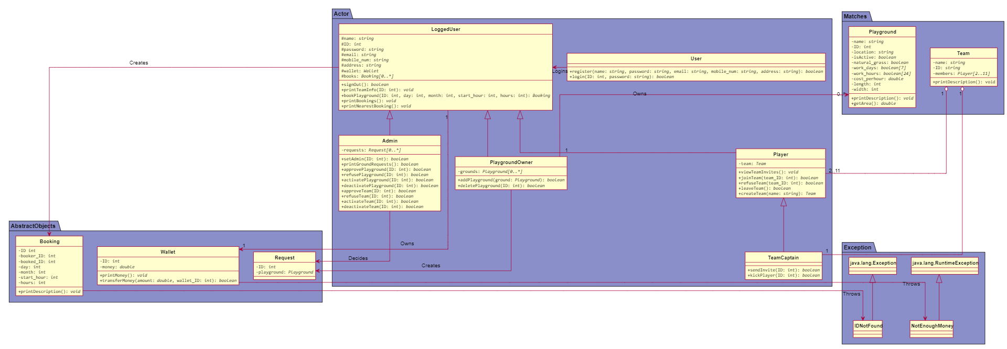

## Class Descriptions

| **Class ID** | **Class Name** | **Description & Responsibility** |
| --- | --- | --- |
| 1. | User | A class that represents a user that is neither registered nor logged in. A user that has just opened a program and only has two responsibilities: to login or register. |
| 2. | LoggedUser | A class that represents a user that is registered and is logged in. Classes: Player, PlaygroundOwner and Admin inherit from this class. Responsibilities: Sign out, Book a playground, view his bookings and check his wallet. |
| 3. | Player | A class that represents a player. Responsibilities: All LoggedUser responsibilites + create a team, view Teams he is invited to and accept or refuse invitations.(See TeamCaptain for more info) |
| 4. | PlaygroundOwner | A class that represents a playground owner, who owns 1 or more playgrounds. Responsibilities: Add or Remove owned Playgrounds. An admin must accept or refuse such requests. |
| 5. | Admin | A class that represents a user with special privileges. An admin is responsible for managing the program. He is responsible for Managing Playground and Team requests. And suspending Playgrounds with bad history. |
| 6. | TeamCaptain | A class that inherits from a player. It represents a normal player but who has created his own team. A team must have one and only one TeamCaptain He is responsible for sending invites to other players and kick players from his team. |
| 7. | Playground | A class that represents a playground. It has many important attributes to determine its name, its location, if it is active, if it has natural grass, its area, its work days, its work hours and its cost. |
| 8. | Team | A class that is created when a player creates his own team. It has only one captain and up to 10 normal players. It also has a name. |
| 9. | Booking | A class to represent a booking that is made by a player to a playground. It saves the ID of the booker, the ID of the booked playground, total cost and the date and duration of the booking. |
| 10. | Wallet | A class that represents a wallet that saves a LoggedUser’s money. Depositing money to the wallet happens out of the system’s boundary. |
| 11. | Request | A class that represents a request made to the admins. It could be a Playground request or a Team creation request. It is deleted when responded by one of the admins. |
| 12. | IDNotFound | An exception that is thrown whenever the user specifies an ID of a player, playground.. etc that doesn’t exist. |
| 13. | NotEnoughMoney | An exception that is thrown when trying to book a playground but the wallet doesn’t have enough money. |

## Sequence diagrams

Add Playground:

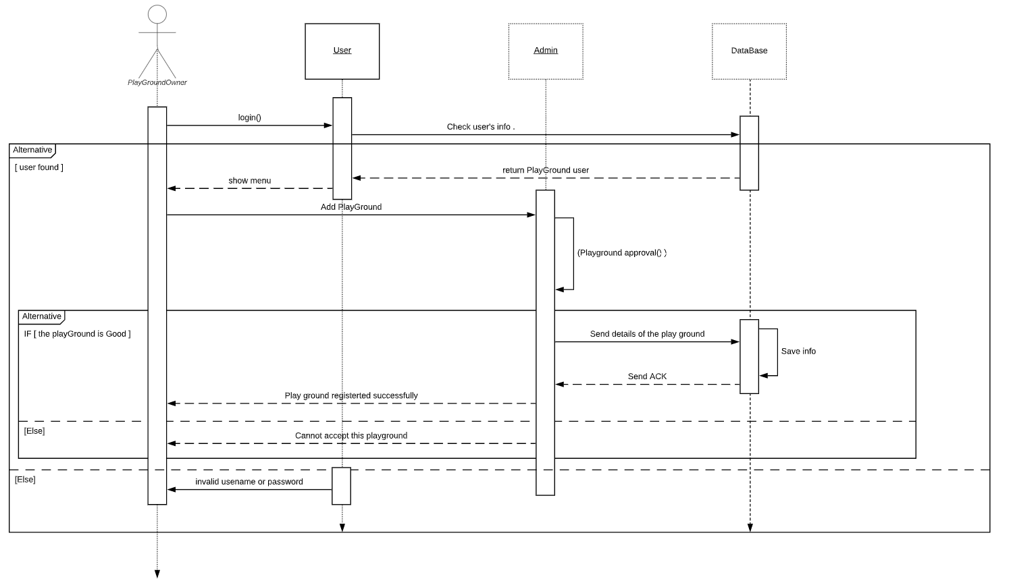

Approve Playground:

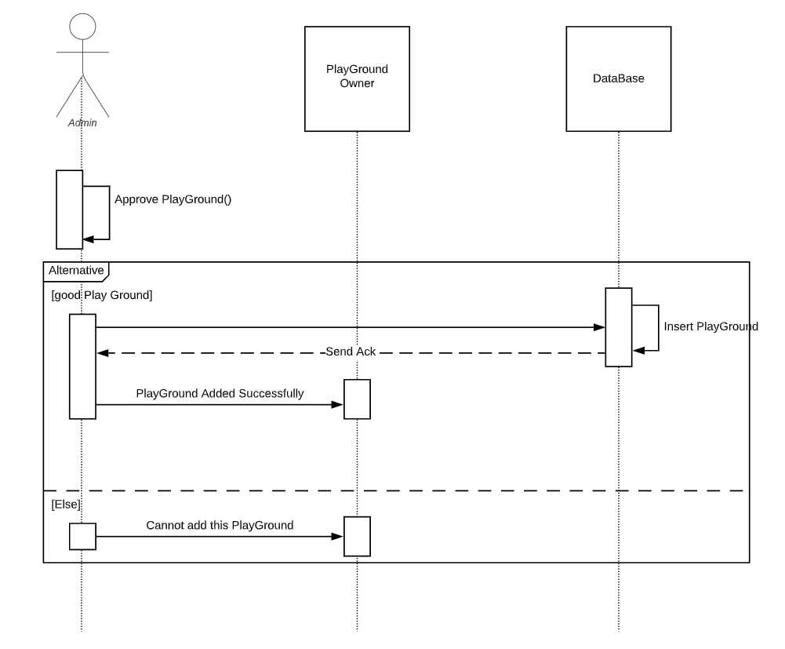

Register user:

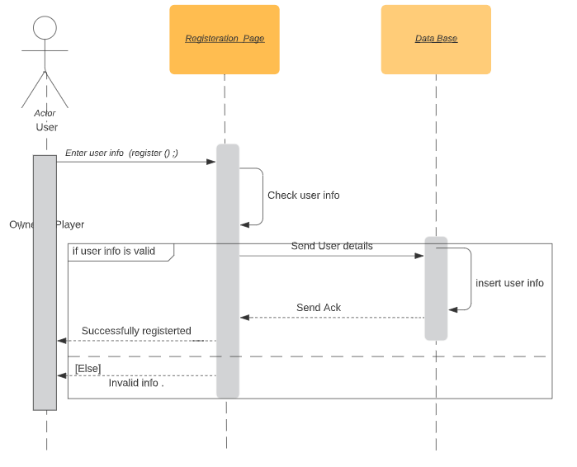

Book a Playground:

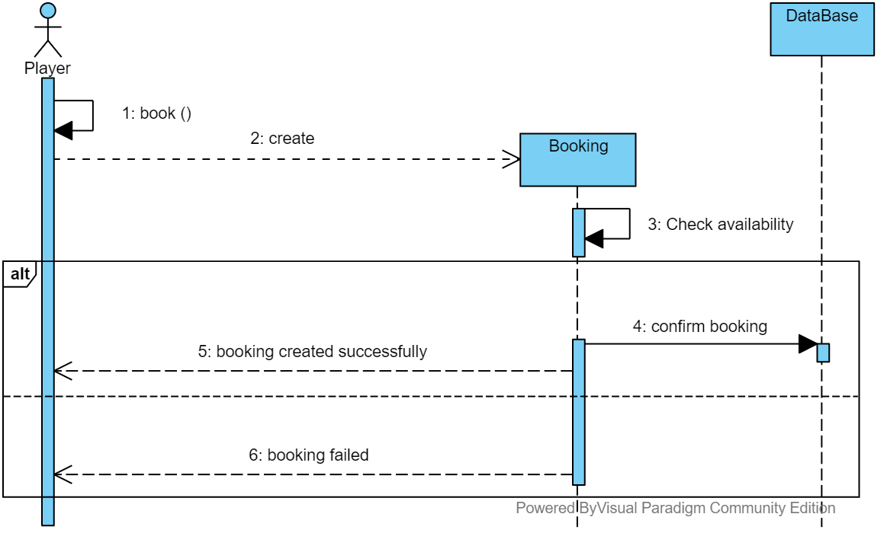

Create team:

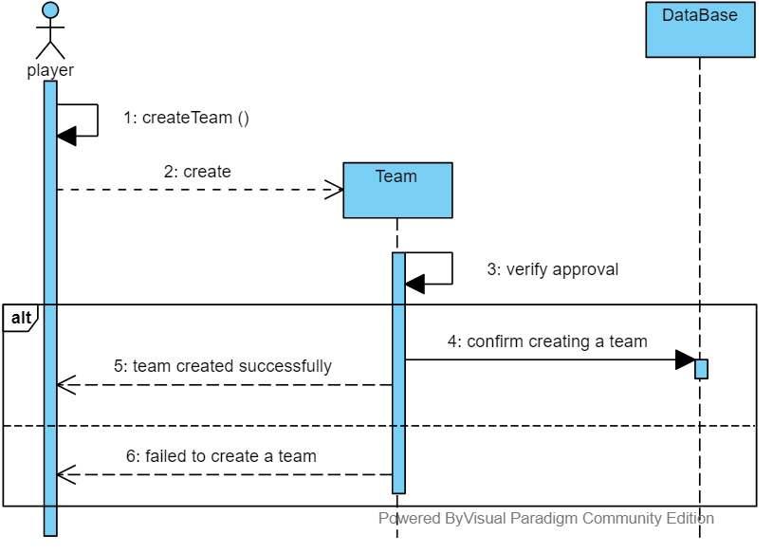

View playing hours:

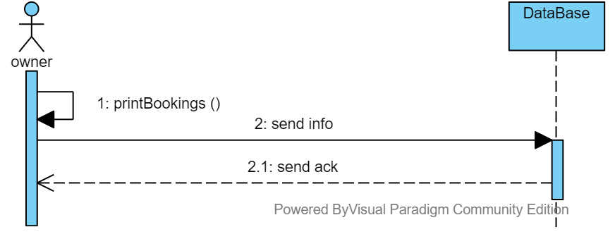

### Class - Sequence Usage Table

| **Sequence Diagram** | **Classes Used** | **All Methods Used** |
| --- | --- | --- |
| 1. Add Playground | Admin  User | login() |
| 1. Approve Playground | PlaygroundOwner | approvePlayground() |
| 1. Book a Playground | Booking | book() |
| 1. Create team | Team | createTeam() |
| 1. Register user | User | Register() |
| 1. View playing hours | PlaygroundOwner | printBookings() |

## User Interface Design

|  |  |  |
| --- | --- | --- |
| **Screen ID** | **Screen Name** | **Screen / Wireframe Description** |
| #1 | Login | Used to login if you have an account |
| #2 | Register | Used to make an account for admin or player or playground owner |
| #3 | Owner Menu | This menu appears when Play Ground owner sign it shows the functionalities of the Owner that he can do in the program. |
| #4 | Adding Play Ground | A form that takes the playground details from the owner to add the playground in the application. |
| #5 | Deleting Play Ground | A form that takes an ID of one of the play grounds of the owner to delete it from the application |
| #6 | Player menu | This menu appears when a player sign it shows the functionalities of the player that he can do in the program. |
| #7 | Booking Play Ground | This screen shows the player ground with their id’s to allow the player to book a playground at a specific time. |
| #8 | Create Team | A form that takes the id’s of the other players to invite them to join to the team of the user. |
| #9 | Join Team | Form that takes the id of the team that the user want to join to send a join request to the captain of the team |
| #10 | Admin Menu | This menu appears when admin sign it shows the functionalities of the admin that he can do in the program. |
| #11 | Show Grounds Requests | A form that shows the playground that need to get an approve from the admin to be added to the application |
| #12 | Play Ground De Activation | A form that takes a playground id to deactivate it. |

Navigation Map for the Screens :

# Tools

* **Visual-Paradigm**
* **Mocqus**
* **Lucidchart**
* **PlantUML**

# Ownership Report

|  |  |
| --- | --- |
| **Owners** | **Item** |
| Mahmoud Ashraf | Three sequence diagrams (first three),User Interface design , Class Diagram  (Admin, PlayGround). |
| Nader Fikry | Three sequence diagrams(last three), SDS document,  Implementation of Abstract Objects package and a video that describes the components of the system. |
| Fady Emad | Class Diagram and Console Implementation |

# Screenshots and Video

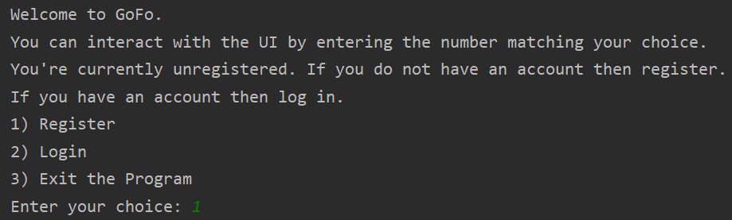

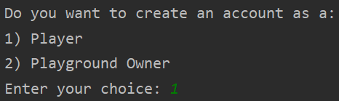

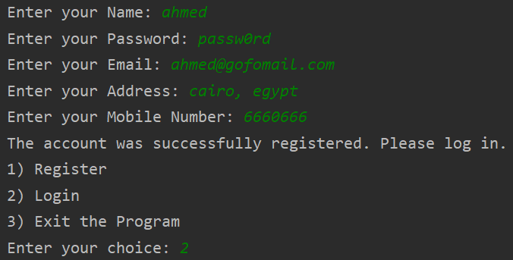

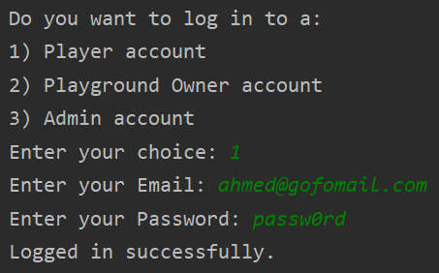

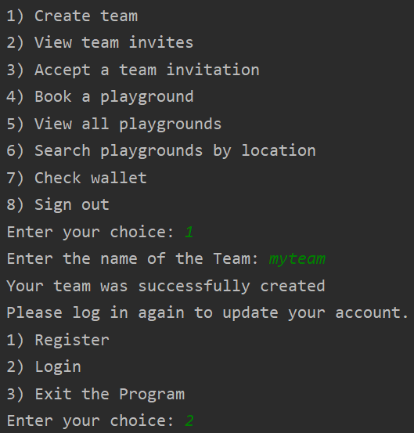

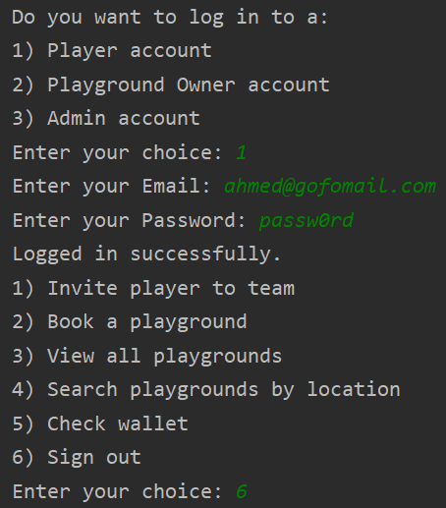

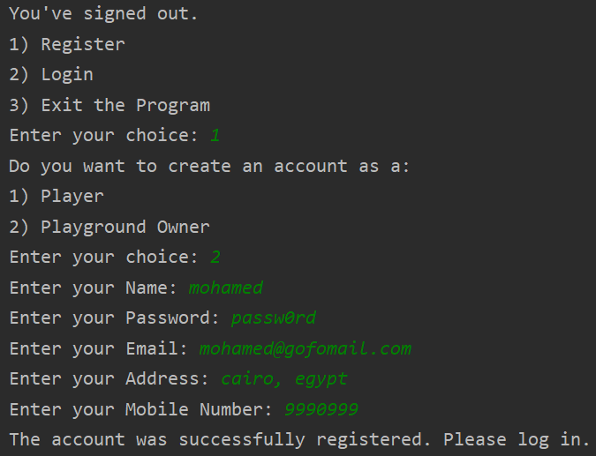

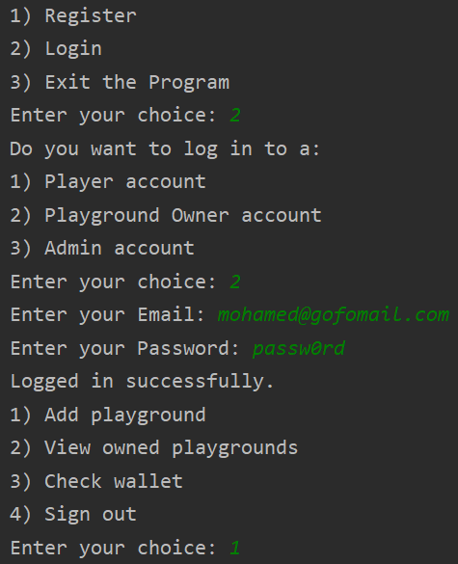

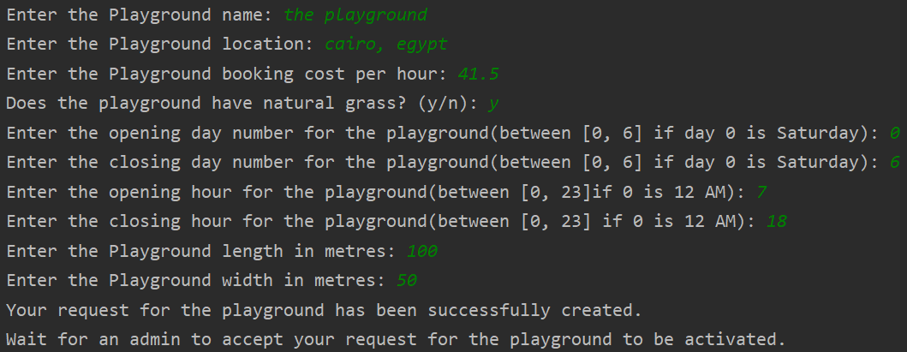

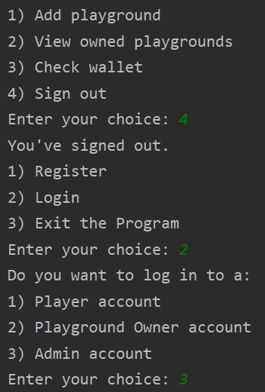

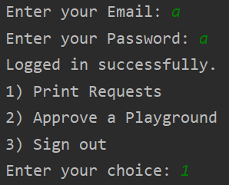

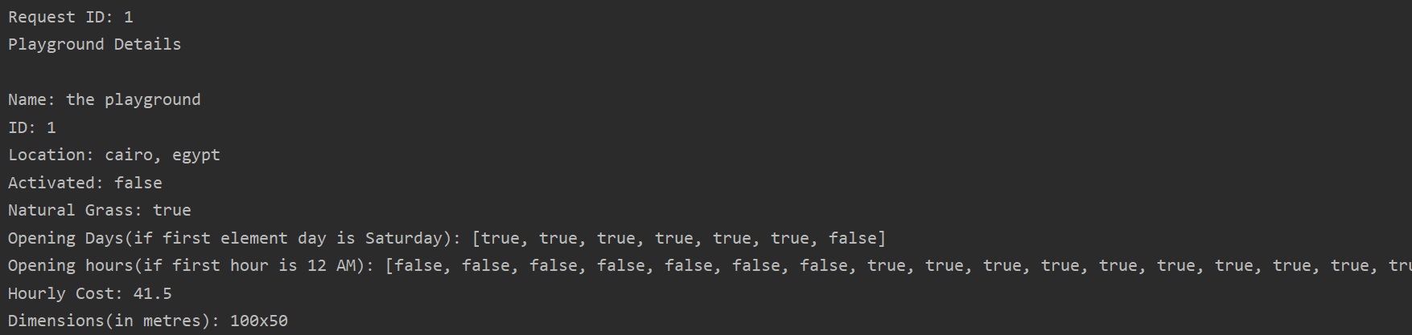

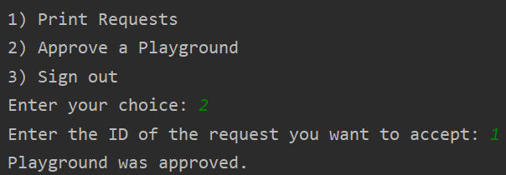

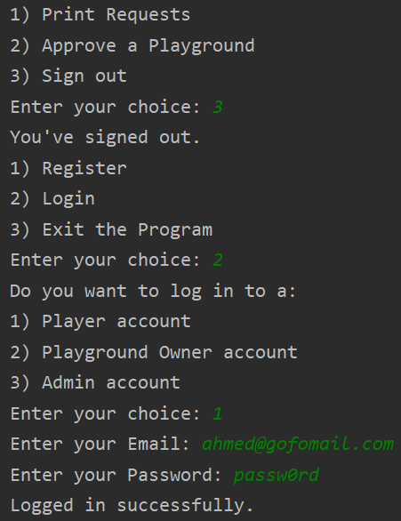

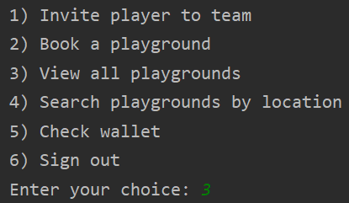

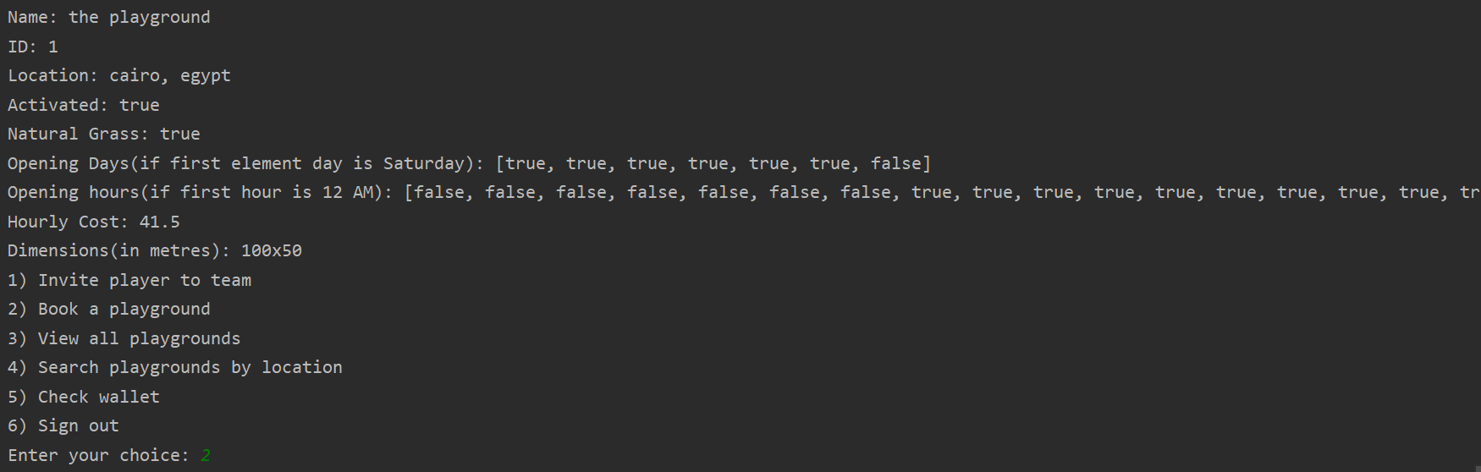

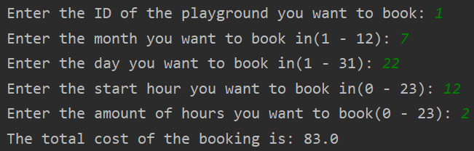

* Link for the video that describes the components of the system:

<https://www.powtoon.com/c/dtnZ89xeHdW/1/m>

# Source Code

The filename is written first then the code inside the file.

**Booking.java:**

**package AbstractObjects;**

**/\*\***

**\* Class representing a booking made by a player to a playground.**

**\* contains required attributes for details regarding the booking**

**\*/**

**public class Booking {**

**private int ID;**

**private int booker_ID;**

**private int booked_ID;**

**private int day;**

**private int month;**

**private int start_hour;**

**private int hours;**

**public Booking(int booker_ID, int booked_ID, int day, int month, int start_hour, int hours) {**

**this.ID = IDGenerator.Booking();**

**this.booker_ID = booker_ID;**

**this.booked_ID = booked_ID;**

**this.day = day;**

**this.month = month;**

**this.start_hour = start_hour;**

**this.hours = hours;**

**}**

**public int getID() {**

**return ID;**

**}**

**/\*\***

**\* getBookerID method to return the value of booker_ID attribute.**

**\* @return**

**\*/**

**public int getBookerID() {**

**return booker_ID;**

**}**

**/\*\***

**\* getBookedID method to return the value of booked_ID attribute.**

**\* @return**

**\*/**

**public int getBookedID() {**

**return booked_ID;**

**}**

**/\*\***

**\* getDay method to return the value of day attribute.**

**\* @return**

**\*/**

**public int getDay() {**

**return day;**

**}**

**/\*\***

**\* getMonth method to return the value of the month attribute.**

**\* @return**

**\*/**

**public int getMonth() {**

**return month;**

**}**

**/\*\***

**\* getStartHour method to return the value of start_hour attribute.**

**\* @return**

**\*/**

**public int getStartHour() {**

**return start_hour;**

**}**

**/\*\***

**\* getHours method to return the value of hours attribute.**

**\* @return**

**\*/**

**public int getHours() {**

**return hours;**

**}**

**/\*\***

**\* printDescription method to print the information of the class.**

**\*/**

**public void printDescription() {**

**System.out.print("The booking ID is: " + getID() + "/nThe booker ID is: " + getBookerID() + "/nThe booked playground ID is: "**

**+ getBookedID() + "/nThe booking day is: " + getDay() + "/nThe booking month is: " + getMonth()**

**+ "/nThe booking start hour is: " +getStartHour() + "/nThe booking hours is: " + getHours());**

**}**

**}**

**Database.java:**

**package AbstractObjects;**

**import java.util.ArrayList;**

**import Actor.Admin;**

**import Actor.Player;**

**import Actor.PlaygroundOwner;**

**import Matches.Playground;**

**import Exception.IDNotFound;**

**/\*\***

**\* A class to store the necessary data registered in the program.**

**\* has an Arraylist attribute for each category(Ex: players, playground owners).**

**\*/**

**public class Database {**

**public static ArrayList<Player> players_accounts = new ArrayList<Player>();**

**public static ArrayList<PlaygroundOwner> playgroundOwners_accounts = new ArrayList<PlaygroundOwner>();**

**public static ArrayList<Admin> admins_accounts = new ArrayList<Admin>();**

**public static ArrayList<Playground> playgrounds = new ArrayList<Playground>(); // this array contains active playgrounds only**

**public static ArrayList<Booking> bookings = new ArrayList<Booking>();**

**/\*\***

**\* Verify a player account as stored in the database**

**\* @param email given email**

**\* @param password given password**

**\* @return null if account doesn't exist. otherwise returns the account**

**\*/**

**public static Player verifyPlayer(String email, String password){**

**for(int i = 0; i < players_accounts.size(); ++i){**

**if(players_accounts.get(i).getEmail().equalsIgnoreCase(email) && players_accounts.get(i).getPassword().equals(password)){**

**return players_accounts.get(i);**

**}**

**}**

**return null;**

**}**

**/\*\***

**\* Verify a playground owner account as stored in the database**

**\* @param email given email**

**\* @param password given password**

**\* @return null if account doesn't exist. otherwise returns the account**

**\*/**

**public static PlaygroundOwner verifyPlaygroundOwner(String email, String password){**

**for(int i = 0; i < playgroundOwners_accounts.size(); ++i){**

**if((playgroundOwners_accounts.get(i).getEmail().equalsIgnoreCase(email)) && (playgroundOwners_accounts.get(i).getPassword().equals(password))){**

**return playgroundOwners_accounts.get(i);**

**}**

**}**

**return null;**

**}**

**/\*\***

**\* Verify an admin account as stored in the database**

**\* @param email given email**

**\* @param password given password**

**\* @return null if account doesn't exist. otherwise returns the account**

**\*/**

**public static Admin verifyAdmin(String email, String password){**

**for(int i = 0; i < admins_accounts.size(); ++i){**

**if(admins_accounts.get(i).getEmail().equalsIgnoreCase(email) && admins_accounts.get(i).getPassword().equals(password)){**

**return admins_accounts.get(i);**

**}**

**}**

**return null;**

**}**

**/\*\***

**\* searches the playgrounds for the given playground ID**

**\*/**

**public static Playground searchPlayground(int ID) {**

**for(int i = 0; i < playgrounds.size(); ++i){**

**if(playgrounds.get(i).getID() == ID){**

**return playgrounds.get(i);**

**}**

**}**

**return null;**

**}**

**/\*\***

**\* Checks if the given email is already registered.**

**\* used for verification while registering**

**\* second parameter decides to search in players or playground owners array**

**\* true for players**

**\* false for playground owners**

**\*/**

**public static boolean isDuplicate(String email, boolean isPlayer){**

**if(isPlayer){**

**for(int i = 0; i < players_accounts.size(); ++i){**

**if(players_accounts.get(i).getEmail().equalsIgnoreCase(email)){**

**return true;**

**}**

**}**

**}**

**else {**

**for(int i = 0; i < playgroundOwners_accounts.size(); ++i){**

**if(playgroundOwners_accounts.get(i).getEmail().equalsIgnoreCase(email)){**

**return true;**

**}**

**}**

**}**

**return false;**

**}**

**public static Player searchPlayer(int ID) {**

**for(int i = 0; i < players_accounts.size(); ++i){**

**if(players_accounts.get(i).getID() == ID){**

**return players_accounts.get(i);**

**}**

**}**

**return null;**

**}**

**}**

**IDGenerator.java:**

**package AbstractObjects;**

**/\*\***

**\* A class to generate unique IDs for different categories in the program**

**\* has methods resembling the different categories. each method returns a unique ID for that category.**

**\*/**

**public class IDGenerator {**

**private static int booking_ID = 0;**

**private static int request_ID = 0;**

**private static int wallet_ID = 0;**

**private static int user_ID = 0;**

**private static int team_ID = 0;**

**private static int playground_ID = 0;**

**public static int Booking(){**

**++booking_ID;**

**return booking_ID;**

**}**

**public static int Request(){**

**++request_ID;**

**return request_ID;**

**}**

**public static int Wallet(){**

**++wallet_ID;**

**return wallet_ID;**

**}**

**public static int User(){**

**++user_ID;**

**return user_ID;**

**}**

**public static int Team(){**

**++team_ID;**

**return team_ID;**

**}**

**public static int Playground(){**

**++playground_ID;**

**return playground_ID;**

**}**

**}**

**Request.java:**

**package AbstractObjects;**

**import Matches.Playground;**

**/\*\***

**\* A class that represents a request made by a playground owner to admins to add a playground**

**\*/**

**public class Request {**

**private int ID;**

**private Playground playground;**

**/\*\***

**\* Parameterized constructor to give the attributes a certain value.**

**\* @param playground Initialize a request with the requested playground**

**\*/**

**public Request(Playground playground) {**

**this.playground = playground;**

**this.ID = IDGenerator.Request();**

**}**

**/\*\***

**\* setID method to set the value of ID attribute.**

**\* @param ID**

**\*/**

**public void setID(int ID) {**

**this.ID = ID;**

**}**

**/\*\***

**\* getID method to return the value of ID attribute.**

**\* @return**

**\*/**

**public int getID() {**

**return ID;**

**}**

**/\*\***

**\* get method to return the requested playground**

**\* @return**

**\*/**

**public Playground getPlayground() {**

**return playground;**

**}**

**}**

**Wallet.java:**

**package AbstractObjects;**

**/\*\***

**\* A class represents the wallet that saves a user's money**

**\*/**

**public class Wallet {**

**private int ID;**

**private double money;**

**/\*\***

**\* Default constructor to initialize the attributes.**

**\*/**

**public Wallet() {**

**this.ID = IDGenerator.Wallet();**

**this.money = 1000;**

**}**

**/\*\***

**\* setMoney method to set the value of the money.**

**\* @param money**

**\*/**

**public void setMoney(double money) {**

**this.money = money;**

**}**

**/\*\***

**\* getMoney method to return the value of the money.**

**\* @return**

**\*/**

**public double getMoney() {**

**return money;**

**}**

**public int getID() {**

**return ID;**

**}**

**/\*\***

**\* printMoney method to print the amount of the money.**

**\*/**

**public void printMoney() {**

**System.out.println("Your current balance is: " + getMoney());**

**}**

**}**

**Admin.java:**

**package Actor;**

**import AbstractObjects.Booking;**

**import AbstractObjects.Database;**

**import AbstractObjects.Request;**

**import Matches.Playground;**

**import Exception.IDNotFound;**

**import java.util.ArrayList;**

**import java.util.Scanner;**

**/\*\***

**\* A user that has special control over the program, such as accepting playgrounds.**

**\*/**

**public class Admin extends LoggedUser {**

**public static ArrayList<Request> requests = new ArrayList<Request>();**

**public Admin(String name, String password, String email, String address, String mobile_num) {**

**super(name, password, email, address, mobile_num);**

**}**

**/\*\***

**\* a static function called for creating a new request for a new playground**

**\* @param playground**

**\*/**

**public static void request(Playground playground){**

**Request req = new Request(playground);**

**requests.add(req);**

**}**

**/\*\***

**\* Prints all the requested playgrounds**

**\*/**

**public void printRequests(){**

**for(int i = 0; i < requests.size(); ++i){**

**System.out.println("\n\nRequest ID: " + requests.get(i).getID());**

**System.out.println(requests.get(i).getPlayground());**

**}**

**}**

**/\*\***

**\* accept a playground in the requests array**

**\*/**

**public void accept() throws IDNotFound {**

**Scanner input = new Scanner(System.in);**

**System.out.print("Enter the ID of the request you want to accept: ");**

**int ID = Integer.parseInt(input.nextLine());**

**for(int i = 0; i < requests.size(); ++i){**

**if(requests.get(i).getID() == ID){**

**requests.get(i).getPlayground().setActive(true);**

**Database.playgrounds.add(requests.get(i).getPlayground());**

**requests.remove(i);**

**System.out.println("Playground was approved.");**

**return;**

**}**

**}**

**throw new IDNotFound();**

**}**

**/\*\***

**\* main menu screen for admin account**

**\*/**

**public void menu(){**

**System.out.println("1) Print Requests\n2) Approve a Playground\n3) Search for an account by name\n4) Sign out");**

**}**

**}**

**LoggedUser.java:**

**package Actor;**

**import AbstractObjects.Booking;**

**import AbstractObjects.Database;**

**import AbstractObjects.IDGenerator;**

**import AbstractObjects.Wallet;**

**import java.util.ArrayList;**

**import java.util.Scanner;**

**/\*\***

**\* Class to resemble a user that has an account in the database in general.**

**\* Player, PlaygroundOwner and Admin inherit from this class.**

**\*/**

**public class LoggedUser {**

**protected String name;**

**protected String password;**

**protected int ID;**

**protected String email;**

**protected String address;**

**protected String mobile_num;**

**protected Wallet wallet;**

**public LoggedUser(String name, String password, String email, String address, String mobile_num) {**

**this.name = name;**

**this.password = password;**

**this.email = email;**

**this.address = address;**

**this.mobile_num = mobile_num;**

**this.wallet = new Wallet();**

**this.ID = IDGenerator.User();**

**}**

**public LoggedUser() { // empty constructor added to initialize team captain from a player without generating a new ID**

**}**

**public String getEmail() {**

**return email;**

**}**

**public String getName() {**

**return name;**

**}**

**public String getPassword() {**

**return password;**

**}**

**public Wallet getWallet() {**

**return wallet;**

**}**

**public int getID() {**

**return ID;**

**}**

**// Allows LoggedUsers to search for an another user's Info using name.**

**// If no matches were found in the three databases nothing will be printed.**

**public void searchUserInfo(){**

**System.out.print("Enter the Username of the User you want to check ID: ");**

**Scanner input = new Scanner(System.in);**

**String name_input = input.nextLine();**

**for (int i = 0; i < Database.admins_accounts.size(); ++i){**

**if(Database.admins_accounts.get(i).getName().equalsIgnoreCase(name_input)){**

**System.out.println("An Admin with this name was found. ID: " + Database.admins_accounts.get(i).getID() + ", Email: " + Database.admins_accounts.get(i).getEmail());**

**}**

**}**

**for (int i = 0; i < Database.playgroundOwners_accounts.size(); ++i){**

**if(Database.playgroundOwners_accounts.get(i).getName().equalsIgnoreCase(name_input)){**

**System.out.println("A Playground Owner with this name was found. ID: " + Database.playgroundOwners_accounts.get(i).getID() + ", Email: " + Database.playgroundOwners_accounts.get(i).getEmail());**

**}**

**}**

**for (int i = 0; i < Database.players_accounts.size(); ++i){**

**if(Database.players_accounts.get(i).getName().equalsIgnoreCase(name_input)){**

**System.out.println("A Player with this name was found. ID: " + Database.players_accounts.get(i).getID() + ", Email: " + Database.players_accounts.get(i).getEmail());**

**}**

**}**

**}**

**@Override**

**public String toString() {**

**return "Name: " + name + "\nEmail: " + email + "\nID: " + ID;**

**}**

**}**

**Player.java:**

**package Actor;**

**import AbstractObjects.Booking;**

**import AbstractObjects.Database;**

**import Matches.Playground;**

**import Matches.Team;**

**import java.util.ArrayList;**

**import java.util.Scanner;**

**import Exception.*;**

**/\*\***

**\* Class to represent a registered Player.**

**\*/**

**public class Player extends LoggedUser {**

**protected Team team;**

**protected ArrayList<Team> team_invitations;**

**protected ArrayList<Booking> bookings;**

**public Player(String name, String password, String email, String address, String mobile_num) {**

**super(name, password, email, address, mobile_num);**

**bookings = new ArrayList<Booking>();**

**team_invitations = new ArrayList<Team>();**

**team = null;**

**}**

**public Player() { // empty constructor added to initialize team captain from a player without generating a new ID**

**}**

**public Team getTeam() {**

**return team;**

**}**

**public ArrayList<Team> getTeam_invitations() {**

**return team_invitations;**

**}**

**/\*\***

**\* Book a playground**

**\* The user enters the id of the playground then the function searches for the playground in each**

**\* playground owner account**

**\*/**

**public void bookPlayground() throws IDNotFound {**

**Scanner input = new Scanner(System.in);**

**System.out.print("Enter the ID of the playground you want to book: ");**

**int ID = Integer.parseInt(input.nextLine());**

**// search if the playground exists and is active**

**Playground playground = Database.searchPlayground(ID);**

**if(playground == null){**

**throw new IDNotFound();**

**}**

**System.out.print("Enter the month you want to book in(1 - 12): ");**

**int month = Integer.parseInt(input.nextLine());**

**System.out.print("Enter the day you want to book in(1 - 31): ");**

**int day = Integer.parseInt(input.nextLine());**

**System.out.print("Enter the start hour you want to book in(0 - 23): ");**

**int start_hour = Integer.parseInt(input.nextLine());**

**System.out.print("Enter the amount of hours you want to book(0 - 23): ");**

**int hours = Integer.parseInt(input.nextLine());**

**while(start_hour + hours > 24){**

**System.out.println("Invalid booking time. Please reenter start hour and amount of hours.");**

**System.out.print("Enter the start hour you want to book in(0 - 23): ");**

**start_hour = Integer.parseInt(input.nextLine());**

**System.out.print("Enter the amount of hours you want to book(0 - 23): ");**

**hours = Integer.parseInt(input.nextLine());**

**}**

**double cost = playground.getCost_per_hour() * hours;**

**System.out.println("The total cost of the booking is: " + cost);**

**if(cost > wallet.getMoney()){**

**throw new NotEnoughMoney();**

**}**

**wallet.setMoney(wallet.getMoney() - cost);**

**playground.getOwner().wallet.setMoney(playground.getOwner().wallet.getMoney() + cost);**

**Booking booking = new Booking(this.ID, ID, day, month, start_hour, hours);**

**Database.bookings.add(booking);**

**}**

**/\*\***

**\* Prints activated playgrounds in the database**

**\*/**

**public void printPlaygrounds(){**

**for(int i = 0; i < Database.playgrounds.size(); ++i){**

**System.out.println(Database.playgrounds.get(i));**

**}**

**}**

**/\*\***

**\* Prints playground with location filter entered by the player.**

**\*/**

**public void searchPlaygroundsLocation(){**

**Scanner input = new Scanner(System.in);**

**System.out.print("Enter the location you want to see playgrounds in: ");**

**String location = input.nextLine();**

**for(int i = 0; i < Database.playgrounds.size(); ++i){**

**if(Database.playgrounds.get(i).getLocation().equalsIgnoreCase(location)) {**

**System.out.println(Database.playgrounds.get(i));**

**}**

**}**

**}**

**/\*\***

**\* Print all team invitations**

**\*/**

**public void printInvitations(){**

**for (int i = 0; i < team_invitations.size(); ++i){**

**System.out.println(team_invitations.get(i));**

**}**

**}**

**/\*\***

**\* Creating a new team.**

**\* The player must not be in a team to create his own team**

**\* the team creator is automatically assigned as the team captain**

**\*/**

**public void createTeam(){**

**Scanner input = new Scanner(System.in);**

**System.out.print("Enter the name of the Team: ");**

**String name = input.nextLine();**

**this.team = new Team(name, this);**

**System.out.println("Your team was successfully created");**

**}**

**/\*\***

**\* Accepting a team that invited the player**

**\*/**

**public void accept(){**

**Scanner input = new Scanner(System.in);**

**System.out.print("Enter the ID of the team you want to accept: ");**

**int ID = Integer.parseInt(input.nextLine());**

**for(int i = 0; i < team_invitations.size(); ++i){**

**if(team_invitations.get(i).getID() == ID){**

**team = team_invitations.get(i);**

**team_invitations.get(i).getMembers().add(this);**

**team_invitations.clear();**

**System.out.println("You joined the team successfully.");**

**return;**

**}**

**}**

**System.out.println("The team with this ID did not invite you or it doesn't exist.");**

**}**

**/\*\***

**\* Main menu screen for the player**

**\*/**

**public void menu(){**

**System.out.println("1) Create team\n2) View team invites\n3) Accept a team invitation\n4) Book a playground\n5) View all playgrounds\n6) Search playgrounds by location\n7) Check wallet\n8) Search for an account by name\n9) Sign out");**

**}**

**}**

**PlaygroundOwner.java:**

**package Actor;**

**import AbstractObjects.Database;**

**import Matches.Playground;**

**/\*\***

**\* Class to represent a registered Playground Owner.**

**\* Has all attributes of a LoggedUser + an array of grounds resembling playgrounds owned.**

**\*/**

**import java.util.ArrayList;**

**import java.util.Scanner;**

**public class PlaygroundOwner extends LoggedUser {**

**private ArrayList<Playground> grounds;**

**public PlaygroundOwner(String name, String password, String email, String address, String mobile_num) {**

**super(name, password, email, address, mobile_num);**

**grounds = new ArrayList<Playground>();**

**}**

**/\*\***

**\* Add a new playground and wait for it to be accepted by an admin**

**\*/**

**public void addPlayground() {**

**Scanner input = new Scanner(System.in);**

**System.out.print("Enter the Playground name: ");**

**String name = input.nextLine();**

**System.out.print("Enter the Playground location: ");**

**String location = input.nextLine();**

**System.out.print("Enter the Playground booking cost per hour: ");**

**double cost_per_hour = Double.parseDouble(input.nextLine());**

**System.out.print("Does the playground have natural grass? (y/n): ");**

**String boolean_input = input.nextLine();**

**boolean natural_grass;**

**if(boolean_input.equalsIgnoreCase("y")){**

**natural_grass = true;**

**}**

**else{**

**natural_grass = false;**

**}**

**System.out.print("Enter the opening day number for the playground(between [0, 6] if day 0 is Saturday): ");**

**int lower = Integer.parseInt(input.nextLine());**

**System.out.print("Enter the closing day number for the playground(between [0, 6] if day 0 is Saturday): ");**

**int upper = Integer.parseInt(input.nextLine());**

**// loop to iterate and assign true to the days between lower and upper limit**

**boolean[] work_days = new boolean[7];**

**for(int i = 0; i < 7; ++i){**

**if(i >= lower && i < upper){**

**work_days[i] = true;**

**}**

**else{**

**work_days[i] = false;**

**}**

**}**

**System.out.print("Enter the opening hour for the playground(between [0, 23]if 0 is 12 AM): ");**

**lower = Integer.parseInt(input.nextLine());**

**System.out.print("Enter the closing hour for the playground(between [0, 23] if 0 is 12 AM): ");**

**upper = Integer.parseInt(input.nextLine());**

**// loop to iterate and assign true to the days between lower and upper limit**

**boolean[] work_hours = new boolean[24];**

**for(int i = 0; i < 24; ++i){**

**if(i >= lower && i < upper){**

**work_hours[i] = true;**

**}**

**else{**

**work_hours[i] = false;**

**}**

**}**

**System.out.print("Enter the Playground length in metres: ");**

**int length = Integer.parseInt(input.nextLine());**

**System.out.print("Enter the Playground width in metres: ");**

**int width = Integer.parseInt(input.nextLine());**

**Playground playground = new Playground(name, location, natural_grass, work_days, work_hours, cost_per_hour, length, width, this);**

**grounds.add(playground);**

**Admin.request(playground);**

**System.out.println("Your request for the playground has been successfully created.");**

**System.out.println("Wait for an admin to accept your request for the playground to be activated.");**

**}**

**/\*\***

**\* Print all playgrounds owned. whether activated or not.**

**\*/**

**public void printPlaygrounds(){**

**for(int i = 0; i < grounds.size(); ++i){**

**System.out.println(grounds.get(i));**

**}**

**}**

**/\*\***

**\* Main menu for the playground owner account**

**\*/**

**public void menu(){**

**System.out.println("1) Add playground\n2) View owned playgrounds\n3) Check wallet\n4) Search for an account by name\n5) Sign out");**

**}**

**}**

**TeamCaptain.java:**

**package Actor;**

**import AbstractObjects.Database;**

**import Exception.IDNotFound;**

**import Matches.Team;**

**import java.util.ArrayList;**

**import java.util.Scanner;**

**/\*\***

**\* A class to represent a player that has created a team.**

**\* a team must have one Team Captain only**

**\*/**

**public class TeamCaptain extends Player {**

**public TeamCaptain(Player player) {**

**this.name = player.name;**

**this.ID = player.ID;**

**this.wallet = player.wallet;**

**this.password = player.password;**

**this.email = player.email;**

**this.address = player.address;**

**this.mobile_num = player.mobile_num;**

**this.bookings = player.bookings;**

**this.team = player.team;**

**this.team_invitations = new ArrayList<Team>();**

**}**

**/\*\***

**\* Invite a player to the captain's team**

**\*/**

**public void invite() throws IDNotFound {**

**if(getTeam().getMembers().size() > 10){**

**System.out.print("The team is full. you can't invite more players.");**

**return;**

**}**

**Scanner input = new Scanner(System.in);**

**System.out.print("Enter the ID of the player you want to invite: ");**

**int ID = Integer.parseInt(input.nextLine());**

**Player player = Database.searchPlayer(ID);**

**if(player == null){**

**throw new IDNotFound();**

**}**

**else{**

**if(player.getTeam() == null){**

**player.getTeam_invitations().add(this.getTeam());**

**System.out.println("The invitation was successfully sent.");**

**}**

**else{**

**System.out.println("The player is already in a team. Invitation failed.");**

**}**

**}**

**}**

**/\*\***

**\* Main menu screen for team captain**

**\*/**

**@Override**

**public void menu() {**

**System.out.println("1) Invite player to team\n2) Book a playground\n3) View all playgrounds\n4) Search playgrounds by location\n5) Check wallet\n6) Search for an account by name\n7) Sign out");**

**}**

**}**

**User.java:**

**package Actor;**

**import AbstractObjects.Database;**

**import ConsoleUI.Main;**

**import java.util.Scanner;**

**/\*\***

**\* A class that is used for any user that has just opened the program. An unregistered user.**

**\*/**

**public class User {**

**/\*\***

**\* Allows the user to register to the program database.**

**\* An email can only be associated with one account. Thus it is used to identify duplicate accounts.**

**\*/**

**public void register() {**

**Scanner input = new Scanner(System.in);**

**System.out.println("Do you want to create an account as a:\n1) Player\n2) Playground Owner");**

**int choice = Main.makeChoice(1, 2);**

**System.out.print("Enter your Name: ");**

**String name = input.nextLine();**

**System.out.print("Enter your Password: ");**

**String password = input.nextLine();**

**System.out.print("Enter your Email: ");**

**String email = input.nextLine();**

**System.out.print("Enter your Address: ");**

**String address = input.nextLine();**

**System.out.print("Enter your Mobile Number: ");**

**String mobile_num= input.nextLine();**

**if(choice == 1){**

**if(Database.isDuplicate(email, true)) {**

**System.out.println("This email is already registered. Registration failed.");**

**}**

**else{**

**Player account = new Player(name, password, email, address, mobile_num);**

**Database.players_accounts.add(account);**

**System.out.println("The account was successfully registered. Please log in.");**

**}**

**}**

**else{**

**if(Database.isDuplicate(email, false)) {**

**System.out.println("This email is already registered. Registration failed.");**

**}**

**else{**

**PlaygroundOwner account = new PlaygroundOwner(name, password, email, address, mobile_num);**

**Database.playgroundOwners_accounts.add(account);**

**System.out.println("The account was successfully registered. Please log in.");**

**}**

**}**

**}**

**/\*\***

**\* Login to a player account using email and password**

**\*/**

**public Player loginPlayer() {**

**Scanner input = new Scanner(System.in);**

**System.out.print("Enter your Email: ");**

**String email = input.nextLine();**

**System.out.print("Enter your Password: ");**

**String password = input.nextLine();**

**return Database.verifyPlayer(email, password);**

**}**

**/\*\***

**\* Login to an owner account using email and password**

**\* The only difference between logins is calling a different database ArrayList**

**\*/**

**public PlaygroundOwner loginPlaygroundOwner() {**

**Scanner input = new Scanner(System.in);**

**System.out.print("Enter your Email: ");**

**String email = input.nextLine();**

**System.out.print("Enter your Password: ");**

**String password = input.nextLine();**

**return Database.verifyPlaygroundOwner(email, password);**

**}**

**/\*\***

**\* Login to an admin account**

**\*/**

**public Admin loginAdmin() {**

**Scanner input = new Scanner(System.in);**

**System.out.print("Enter your Email: ");**

**String email = input.nextLine();**

**System.out.print("Enter your Password: ");**

**String password = input.nextLine();**

**return Database.verifyAdmin(email, password);**

**}**

**/\*\***

**\* Main menu screen for the User class**

**\*/**

**public void menu(){**

**System.out.println("1) Register\n2) Login\n3) Exit the Program");**

**}**

**}**

**Main.java:**

**// This is a console implementation of project GoFo**

**// The wallet is initialized by default to 1000 pounds to test some functionalities**

**// An admin, player and playground owners accounts were added to Database class for testing**

**package ConsoleUI;**

**import AbstractObjects.Database;**

**import Actor.*;**

**import Exception.*;**

**import Matches.Playground;**

**import java.util.Scanner;**

**public class Main {**

**/\*\***

**\* Function the takes an integer choice from the user and returns the choice.**

**\* Used for main interaction with Console UI.**

**\* Has a lower and upper value to force user input to be in the range**

**\* @return the choice entered by the player**

**\*/**

**public static int makeChoice(int lower, int upper){**

**Scanner input = new Scanner(System.in);**

**System.out.print("Enter your choice: ");**

**int choice = Integer.parseInt(input.nextLine());**

**while(choice < lower || choice > upper){**

**System.out.println("Please enter a valid number matching your choice. ");**

**System.out.print("Enter your choice: ");**

**choice = Integer.parseInt(input.nextLine());**

**}**

**return choice;**

**}**

**public static void main(String[] args) throws IDNotFound, IDNotFound {**

**// added some accounts just to test functionalities**

**Database.admins_accounts.add(new Admin("a", "a", "a", "a", "a"));**

**Database.players_accounts.add(new Player("a", "a", "a", "a", "a"));**

**Database.playgroundOwners_accounts.add(new PlaygroundOwner("a", "a", "a", "a", "a"));**

**// Welcome messages.**

**System.out.println("Welcome to GoFo.");**

**System.out.println("You can interact with the UI by entering the number matching your choice.");**

**System.out.println("You're currently unregistered. If you do not have an account then register.");**

**System.out.println("If you have an account then log in.");**

**// Main loop of the program.**

**User user = new User();**

**while(true){**

**// menu screen**

**user.menu();**

**int choice = makeChoice(1, 3);**

**// register choice**

**if(choice == 1) {**

**user.register();**

**}**

**// login choice**

**else if(choice == 2){**

**System.out.println("Do you want to log in to a:\n1) Player account\n2) Playground Owner account\n3) Admin account");**

**choice = makeChoice(1, 3);**

**// player choice**

**if(choice == 1){**

**Player account = user.loginPlayer();**

**if(account == null) {**

**System.out.println("Failed to log in. invalid credentials.");**

**}**

**// logged in as a player and is the captain of his team**

**else if((account.getTeam() != null) && (account.getTeam().getCaptain().getEmail().equals(account.getEmail()))){**

**System.out.println("Logged in successfully.");**

**TeamCaptain captain_account = new TeamCaptain(account);**

**while(true) {**

**captain_account.menu();**

**choice = makeChoice(1, 7);**

**if(choice == 1){**

**captain_account.invite();**

**}**

**else if(choice == 2){**

**captain_account.bookPlayground();**

**}**

**else if(choice == 3){**

**captain_account.printPlaygrounds();**

**}**

**else if(choice == 4){**

**account.searchPlaygroundsLocation();**

**}**

**else if(choice == 5){**

**System.out.println("Your current balance is: " + account.getWallet().getMoney());**

**}**

**else if(choice == 6){**

**account.searchUserInfo();**

**}**

**else{**

**System.out.println("You've signed out.");**

**break;**

**}**

**}**

**}**

**// logged in as a player and is not captain of his team or is not in a team**

**else{**

**System.out.println("Logged in successfully.");**

**while(true){**

**account.menu();**

**choice = makeChoice(1, 9);**

**if(choice == 1){**

**account.createTeam();**

**System.out.println("Please log in again to update your account.");**

**break; // had to log out a player who has just created a team to enter the loop of TeamCaptain**

**}**

**else if(choice == 2){**

**account.printInvitations();**

**}**

**else if(choice == 3){**

**account.accept();**

**}**

**else if(choice == 4){**

**account.bookPlayground();**

**}**

**else if(choice == 5){**

**account.printPlaygrounds();**

**}**

**else if(choice == 6){**

**account.searchPlaygroundsLocation();**

**}**

**else if(choice == 7){**

**System.out.println("Your current balance is: " + account.getWallet().getMoney());**

**}**

**else if(choice == 8){**

**account.searchUserInfo();**

**}**

**else{**

**System.out.println("You've signed out.");**

**break;**

**}**

**}**

**}**

**}**

**// playground owner choice**

**else if(choice == 2){**

**PlaygroundOwner account = user.loginPlaygroundOwner();**

**if(account == null) {**

**System.out.println("Failed to log in. invalid credentials.");**

**}**

**// logged in as a playground owner**

**else{**

**System.out.println("Logged in successfully.");**

**while(true) {**

**account.menu();**

**choice = makeChoice(1, 5);**

**if(choice == 1){**

**account.addPlayground();**

**}**

**else if(choice == 2){**

**account.printPlaygrounds();**

**}**

**else if(choice == 3) {**

**System.out.println("Your current balance is: " + account.getWallet().getMoney());**

**}**

**else if(choice == 4){**

**account.searchUserInfo();**

**}**

**else{**

**System.out.println("You've signed out.");**

**break;**

**}**

**}**

**}**

**}**

**else{**

**Admin account = user.loginAdmin();**

**if(account == null) {**

**System.out.println("Failed to log in. invalid credentials.");**

**}**

**// logged in as an admin**

**else{**

**System.out.println("Logged in successfully.");**

**while(true) {**

**account.menu();**

**choice = makeChoice(1, 4);**

**if(choice == 1){**

**account.printRequests();**

**}**

**else if(choice == 2){**

**account.accept();**

**}**

**else if(choice == 3){**

**account.searchUserInfo();**

**}**

**else{**

**System.out.println("You've signed out.");**

**break;**

**}**

**}**

**}**

**}**

**}**

**// quit the program choice**

**else {**

**break;**

**}**

**}**

**}**

**}**

**IDNotFound.java:**

**package Exception;**

**/\*\***

**\* An exception that is thrown whenever an ID is searched but is not found in the database**

**\*/**

**public class IDNotFound extends java.lang.Exception {**

**}**

**NotEnoughMoney.java:**

**package Exception;**

**/\*\***

**\* An exception that is thrown whenever money transaction is made without enough money in wallet**

**\*/**

**public class NotEnoughMoney extends java.lang.RuntimeException {**

**}**

**Playground.java:**

**package Matches;**

**import AbstractObjects.IDGenerator;**

**import Actor.PlaygroundOwner;**

**import java.util.Arrays;**

**/\*\***

**\* A class for a playground. Which players book and playground owners own.**

**\*/**

**public class Playground {**

**private String name;**

**private int ID;**

**private String location;**

**private boolean isActive;**

**private boolean natural_grass;**

**private boolean[] work_days;**

**private boolean[] work_hours;**

**private double cost_per_hour;**

**private int length;**

**private int width;**

**private PlaygroundOwner owner;**

**public Playground(String name, String location, boolean natural_grass, boolean[] work_days, boolean[] work_hours, double cost_per_hour, int length, int width, PlaygroundOwner owner) {**

**this.name = name;**

**this.location = location;**

**this.natural_grass = natural_grass;**

**this.work_days = work_days;**

**this.work_hours = work_hours;**

**this.cost_per_hour = cost_per_hour;**

**this.length = length;**

**this.width = width;**

**this.isActive = false;**

**this.owner = owner;**

**this.ID = IDGenerator.Playground();**

**}**

**public int getID() {**

**return ID;**

**}**

**public double getCost_per_hour() {**

**return cost_per_hour;**

**}**

**public PlaygroundOwner getOwner() {**

**return owner;**

**}**

**public void setActive(boolean active) {**

**isActive = active;**

**}**

**public String getLocation() {**

**return location;**

**}**

**@Override**

**public String toString() {**

**return "Playground Details\n" +**

**"\nName: " + name +**

**"\nID: " + ID +**

**"\nLocation: " + location +**

**"\nActivated: " + isActive +**

**"\nNatural Grass: " + natural_grass +**

**"\nOpening Days(if first element day is Saturday): " + Arrays.toString(work_days) +**

**"\nOpening hours(if first hour is 12 AM): " + Arrays.toString(work_hours) +**

**"\nHourly Cost: " + cost_per_hour +**

**"\nDimensions(in metres): " + length + "x" + width;**

**}**

**}**

**Team.java:**

**package Matches;**

**import AbstractObjects.IDGenerator;**

**import Actor.Player;**

**import Actor.TeamCaptain;**

**import java.util.ArrayList;**

**/\*\***

**\* A class to represent a team which has 1 captain and up to 10 players(members)**

**\*/**

**public class Team {**

**private String name;**

**private int ID;**

**private ArrayList<Player> members; // array of players in the team not including the team captain. maximum number of members is 10**

**private TeamCaptain captain; // each team must have a captain**

**public Team(String name, Player captain) {**

**this.name = name;**

**this.members = new ArrayList<Player>();**

**this.captain = new TeamCaptain(captain);**

**this.ID = IDGenerator.Team();**

**}**

**public TeamCaptain getCaptain() {**

**return captain;**

**}**

**public int getID() {**

**return ID;**

**}**

**public ArrayList<Player> getMembers() {**

**return members;**

**}**

**@Override**

**public String toString() {**

**return "Team name: " + name +**

**"\nTeam ID: " + ID +**

**"\nTeam Captain Email: " + captain.getEmail();**

**}**

**}**